[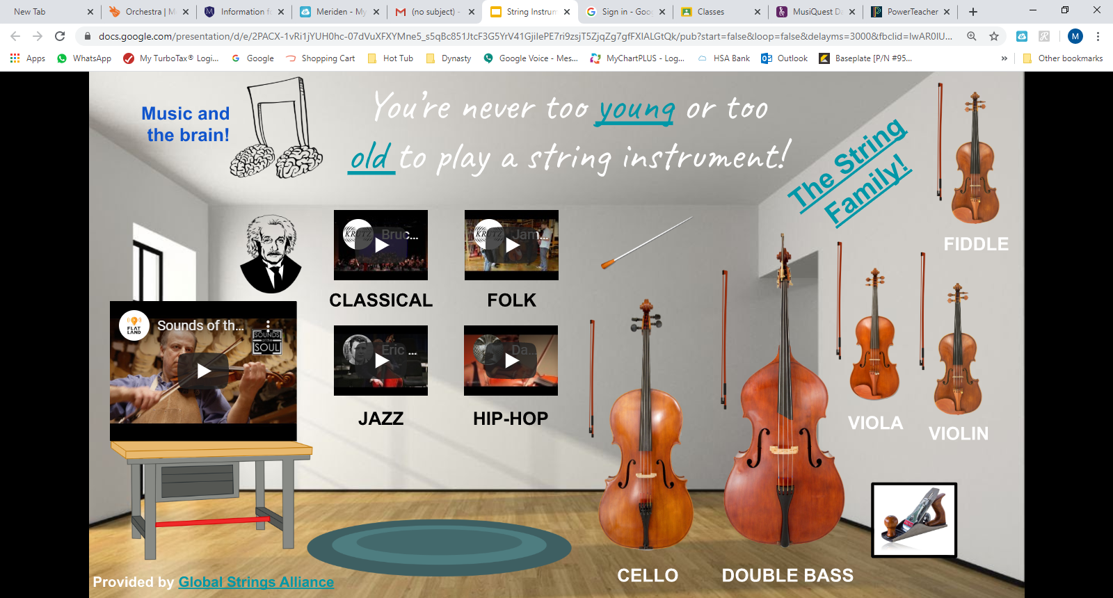](https://docs.google.com/presentation/d/e/2PACX-1vRi1jYUH0hc-07dVuXFXYMne5_s5qBc851JtcF3G5YrV41GjiIePE7ri9zsjT5ZjqZg7gfFXIALGtQk/pub?start=false&loop=false&delayms=3000&fbclid=IwAR0lUKsr1AIiJ4vuAtmmKymLIV_9RcDLWQDL5RrdALibEVDfgLO_li9c-Ts&slide=id.p)